Survey Tries to Measure Whether Local Jury Pools Reflect Population
By Joel Stashenko
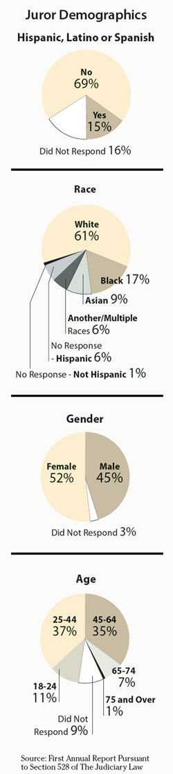
December 7, 2011

ALBANY - New Yorkers of Hispanic heritage may be under-represented among those called for jury duty in some state courts, according to the results of a new survey released yesterday.

In New York City's five boroughs, for example, Hispanics represented a smaller share of potential jurors than of the general population, the report showed. The court system conducted the survey between September 2010 and October 2011 at the behest of the Legislature.

Hispanics represented 51 percent of the city's population in the 2010 U.S. Census but only 47 percent of those who presented themselves for jury duty. They were 26 percent of the population but only 17 percent of jurors in Queens, 23 percent of the Manhattan population but 18 percent of jurors, 19 percent of the Brooklyn population but 15 percent of jurors and 15 percent of the Staten Island population but 11 percent of jurors.

But court administrators cautioned that the juror surveys may not tell the whole story about whether the composition of juries is in line with the demographics.

Ronald Younkins, the courts' director of operations, said that the survey did not reflect how many jurors did not report for duty because they are illegal immigrants, felons or are deficient in English-language skills.

He also pointed out that U.S. Census numbers count all Hispanics, including those who are under 18 and too young to serve on juries.

In general, the survey indicated that statewide, prospective jurors identified themselves in roughly the same proportions as the general population, as reflected by the census in terms of age, gender, race and ethnicity.

Fifteen percent identified themselves as of Hispanic origin, compared with the 16 percent of the population in the 2010 census.

Fifty-two percent of the 439,573 trial jurors and 24,147 grand jurors responding to the state questionnaires were women, the same percentage as in the general population.

Sixty-one percent of jurors identified themselves as white, compared with 67 percent of New Yorkers in general. Seventeen percent of jurors said they were black versus 15 percent of the general population, according to census data.

The requirement that jurors be asked about their ethnic backgrounds was approved under §528 of the Judiciary Law by the Legislature in 2010 as the Jury Pool Fair Representation Act (NYLJ, Sept. 17, 2010).

A sponsor of the reporting requirement, Assemblyman Rory Lancman, D-Queens, said he wanted to ensure that jurors were being drawn from pools that are a fair representation of the demographic background of the counties in which their courts are located.

He held a public hearing in 2009 that prompted the Legislature to act on the bill requiring the disclosure of the juror information.

Mr. Lancman said yesterday the courts' report suggested further areas of inquiry.

In addition to the presence of Hispanics on juror pools, he questioned why blacks were under-represented in Erie, Monroe and Westchester counties.

According to the report, blacks made up 7 percent of the potential jury pools in Erie County compared with 12 percent in the county's general population; 8 percent of the prospective jury pool in Monroe County compared to 13 percent; and 11 percent of jury pools in Westchester County compared to 14 percent.

"I love this stuff," Mr. Lancman said in an interview. "This is exactly what we should be doing. I would like to see us have a follow-up hearing and get some input from scholars and representatives of some communities that are under-represented."

Suggestions for Outreach

The report released yesterday by Acting Supreme Court Justice Ann Pfau, who left at the end of November as chief administrative judge (NYLJ, Oct. 24), suggested possible changes to encourage better participation by those summoned for jury duty.

They included better outreach through groups in minority communities "to improve communication with and response rates from these communities."

The report said that the courts also could use "targeted replacement mail" into the zip codes where residents/potential jurors did not initially respond to summons to appear as jurors. Or it could increase the number of jury notices sent to all addresses in areas with high non-response rates of summonses.

But Judge Pfau said neither approach can be done without statutory changes.

"Each of these approaches replaces true random selection with oversampling from communities with higher undeliverable and non-response rates, and thus represents a shift away from the long-standing public policy, embodied in statute, that fairness and representativeness require a pure random selection process," she stated in the report. "Detailed study would be required to assure that a targeted mailing approach would not adversely affect juror representation or subject some citizens to more frequent jury service."

Mr. Lancman said making special efforts to target certain ethnic groups would require legislative action.

"It needs a bill," Mr. Lancman said. "I don't know if the [state] Constitution would be offended by a system that focuses on under-represented communities in order to achieve a fairly representative result at jury-pool level."

The jury questionnaire bill was sponsored in the Senate by Senator Jeffrey Klein, D-Bronx.

Jurors were also asked their age for the first time.

The highest percentages of those called to jury duty were in the 25-to-44 age group (37 percent) and 45-to-64 age group (35 percent), roughly similar to the population as a whole, the OCA study said

The report said those prospective jurors over age 75 totaled about 8 percent of the population in general, but only about 1 percent of those who ultimately sat on a trial or grand jury. The report attributed that to exemptions granted to such jurors due to health considerations.

Before the introduction of the new questionnaires, jurors in New York were asked only if they resided in the jurisdiction of the court in which they were called, their genders and the last time they served on a jury.

There were no penalties for refusal to answer the questions. The OCA said 27,662 jurors who reported for duty did not complete the questionnaires.

The surveys will be conducted each year and the results reported to the governor and the Legislature.

AD-025

